Accelerating Transport Decarbonization in India: Monitoring, Learning & Evaluation

|  |
| --- |
| Mid-Year Report  July 2022 |

About Oxford Policy Management

Oxford Policy Management is committed to helping low- and middle-income countries achieve growth and reduce poverty and disadvantage through public policy reform.

We seek to bring about lasting positive change using analytical and practical policy expertise. Through our global network of offices, we work in partnership with national decision makers to research, design, implement, and evaluate impactful public policy.

We work in all areas of social and economic policy and governance, including health, finance, education, climate change, and public sector management. We draw on our local and international sector experts to provide the very best evidence-based support.

Table of contents

1 Introduction 1

1.1 Project background and objectives 1

1.2 Scope of work for MLE 2

1.3 Work carried out during the Inception Phase 4

1.4 Deliverables and Timelines 4

1.5 Workplan 1

2 Monitoring, Learning and Evaluation Framework 1

2.1 Monitoring, Learning and Evaluation (MLE) Framework 1

2.2 Illustrative Evaluation Questions (EQs) 3

3 Theory of Change 6

4 Results Framework 20

5 Tracking Evidence: Dashboard Concept Note 24

5.2 Proposal of a complementary data system 26

5.3 Role of partners to report results 28

5.4 Role of M&E team to report on secondary data sources 29

5.5 Content of dashboard 30

5.6 Software and costs 32

6 Learning & Reflection 34

6.1 Purpose of the Learning System 34

6.2 Key principles of the learning system 35

6.3 Framework for the Learning System 35

7 Risk mitigation 40

Annex A: MLE Reporting Template 41

Annex B: Example of Partner’s Guide to Report Against ZEV/EV Related Results (to be finalised) 42

List of abbreviations

|  |  |
| --- | --- |
| CAFE | Corporate Average Fuel Efficiency |
| EV | Electric Vehicle |
| ICE | Internal Combustion Engine |
| KPI | Key Performance Indicators |
| MoHUA | Ministry of Housing and Urban Affairs |
| MoRTH | Ministry of Road Transport and Highways |
| OPM | Oxford Policy Management |
| PoC Investment | Proof of Concept Investment |
| RC | Result Chains |
| T4All | Transport4All Challenge |
| ToC | Theory of Change |
| ZEV | Zero Emissions Vehicle |

# Introduction

## Project background and objectives

Oxford Policy Management (OPM) has been contracted by CIFF to provide monitoring, learning and evaluation support for its programme on ‘Accelerating Transport Decarbonization in India.’ The long-term goal of this project is to put India on a path of rapid decarbonisation of its transport sector to achieve a 45% reduction in CO2 emissions by 2030 over a Business as Usual (BAU) scenario. By 2023, the project is expected to unlock policy, technology, and market-related barriers to electric vehicle (EV) adoption and modal shift and place India on the path to low-carbon transportation systems.

The contract duration for OPM as an independent MLE partner is from 1st October 2021 to 31st December 2022. The overarching goal of the MLE project is to provide CIFF with ongoing assessments and evidence it needs to assess the progress of this Proof of Concept (PoC) investment and make any necessary course corrections in order to improve the design of the programme going forward.

The PoC investment is comprised of activities that fall under four tactics, which are being implemented by six partners: (i) Rocky Mountain Institute (RMI) which is the lead implementing organisation and acts as a coordinating partner for this investment; (ii) International Council on Clean Transportation (ICCT) focuses its activities on accelerating transport decarbonisation in India through fuel efficiency improvements and vehicle electrification; (iii) Urban Works Institute (UWI; formerly partnering with Institute for Transportation and Development Policy (ITDP)) focuses on strengthening public transport in Indian cities; (iv) The Energy and Resources Institute (TERI) focuses on strategies to increase railways’ share in freight transport in India; (v) Confederation of Indian Industry (CII) creates and manages industry platform for scaling EV technologies; and (vi) Edelman India focuses on engagement and outreach to support the work under the investment and has been directly contracted by CIFF and report its progress directly/separately to CIFF.

The two-year PoC investment started in December 2020 and its implementation is currently in progress and meeting most targets despite the ongoing Covid-19 pandemic. The two key levers of ‘zero emissions vehicle (ZEV) deployment’ and ‘modal shift’ are expected to accelerate the decarbonization of India’s transport sector. Based on the recent Annual Report submitted by RMI and other partners in November 2021, key highlights of the partners’ work over the past year include:

* + - * Key national and state level policies and schemes on EVs announced/amended, with RMI’s technical support, including Maharashtra, FAME II scheme, PLI scheme for domestic battery manufacturing, and others, leading to a cumulative commitment of approximately USD 4 billion in national and sub-national public funds to support EV deployment and battery manufacturing.
      * RMI drove the agenda on EVs with key stakeholders through publishing key reports such as on mobilizing finance for EVs, etc.
      * Pioneering national initiatives launched, such as the Shoonya campaign for zero emission passenger and delivery vehicles; the State EV policy accelerator; and progress towards the City EV policy accelerator.
      * Launched Transport4All Challenge: ITDP India, in partnership with Ministry of Housing and Urban Affairs (MoHUA), launched the Transport4All Challenge to make public transport safe, convenient, and affordable for all, with participation from 130 cities.
      * Support to MoHUA’s bus augmentation program: The national government allocated INR 18,000 crores for over 20,000 new buses as part of its budget announcement for the financial year 2021–22. ITDP India has offered and plans to support MoHUA on this program through its Transport4All Challenge.

There have been some challenges due to COVID-19 and political economic context within and outside the project, but these appear to have been resolved and the work progress seems to be on track according to the Annual Report. OPM’s task as the MLE partner is to establish verifiable links/causal pathways between these activities and measurable indicators of progress towards outcomes and overall programme’s objectives.

## Scope of work for MLE

OPM’s scope of work is based on the terms of reference issued by CIFF for the project and the detailed project proposal submitted by OPM. The two broad focus objectives for the MLE project are:

1. **Reporting on the progress of results**
   1. To what extent is there evidence the PoC investment has made progress and delivered results in line with its Key Performance Indicators (KPIs)?
   2. What are the data and evidence sources (and how reliable are they) to support future KPI progress and wider investment results reporting?
2. **Assessing avenues for course corrections and wider programmatic learning**
   1. What key course corrections should CIFF, and its partners make in any future investment beyond the PoC?
   2. What wider key lessons and learning has the PoC investment generated in the field of accelerating transport decarbonization?

From the TOR, as MLE partner OPM is also tasked to help CIFF and key stakeholders by sharing information and relevant analysis on the following questions and related KPIs:

1. How and to what extent has this investment increased the adoption of ZEVs?

a. % EVs in new vehicle sales

b. (2Ws, 3Ws)

c. # market ready electric vehicle models

2. To what extent has this investment unlocked FAME II funding to support EV infrastructure?

a. FAME II funds utilised for charging infrastructure

b. # public charging infra points installed

c. # cities with bus schemes

d. % of buses that are electric

3. How this investment has facilitated enabled the roll out of large-scale EV component manufacturing plans?

4. To what extent has this IM supported the EV ecosystem to mature and rapidly expand the industry?

a. % price differential between key ICE and EVs vehicle classes

The specific activities and outputs within in this scope of work have been revisited during the inception period and further fine-tuned to suit CIFF’s reporting needs. For example, there have been extensive discussions with CIFF and implementing partners around more micro-level indicators (outputs and intermediate outcomes) and how these micro-level indicators can feed into the macro-level KPIs outlined above. Moreover, there is also an additional question around the second lever, i.e., modal shift, which needs to be added to the list above and relevant KPIs to measure the progress on modal shift-related activities. Throughout the implementation phases, OPM will work closely with CIFF to ensure that the overarching MLE system as well as the individual deliverables meet their needs and expectation.

In summary, OPM’s MLE assignment comprises of three key work streams aimed to deliver the objectives stated above:

1. **Monitoring:** This includes developing and reporting against the Theory of Change, Results Framework.
2. **Learning:** Based on a mapping of existing partner learning requirements, OPM will work on solidifying internal and external facing learning activities across the programme duration. This will involve setting up a database to log partner progress against a pre-agreed set of learning topics (TBD) and producing learning outputs based on partner reporting. Two learning workshops will be conducted as agreed with CIFF: one in April and another in October 2022.
3. **Evaluation:** OPM will produce two programme evaluations (mid-year and annual) to assess and validate programme achievements.

## Deliverables and Timelines

The deliverables and timelines have been discussed with CIFF during the Inception Phase. The list of revised key deliverables and corresponding dates are listed in Table 1.

**Table 1: Key Deliverables and Due Dates**

|  |  |
| --- | --- |
| Deliverable | Due Date |
| Inception Report, Results Framework | 31/01/2022 |
| First draft of the data management  dashboard | 31/01/2022 |
| First Learning Workshop | 15/04/2022 |
| Half Yearly Report including analysis  of retrospective programme data and  first Learning insights | **04/07/2022**  **\***Learning case study will be submitted  end of July |
| Second Learning Workshop | 15/10/2022 |
| Interaction with external stakeholders | 31/10/2022 |
| Final Report with complete data  analysis and Learning Insights | 31/12/2022 |
| Quarterly updates on programme data & indicators | Every quarter |

## Workplan

As per the discussion with CIFF and the key deliverables outlined above, we have updated our activities and outputs during the Inception Phase and are illustrated below**.**

| ***Activity/Deliverables*** | ***2021*** | | | ***2022*** | | | | | | | | | | | |
| --- | --- | --- | --- | --- | --- | --- | --- | --- | --- | --- | --- | --- | --- | --- | --- |
| ***Oct*** | ***Nov*** | ***Dec*** | ***Jan*** | ***Feb*** | ***Mar*** | ***Apr*** | ***May*** | ***Jun*** | ***Jul*** | ***Aug*** | ***Sep*** | ***Oct*** | ***Nov*** | ***Dec*** |
| **Inception Phase** | | | |  |  |  |  |  |  |  |  |  |  |  |  |
| **Kick-off calls** |  |  |  |  |  |  |  |  |  |  |  |  |  |  |  |
| **Programme documentation review** |  |  |  |  |  |  |  |  |  |  |  |  |  |  |  |
| **ToC workshop** |  |  |  |  |  |  |  |  |  |  |  |  |  |  |  |
| **MLE Protocol and Agreement** |  |  |  |  |  |  |  |  |  |  |  |  |  |  |  |
| **Literature review and one-to-one interviews with partners** |  |  |  |  |  |  |  |  |  |  |  |  |  |  |  |
| **Results Framework Development** |  |  |  |  |  |  |  |  |  |  |  |  |  |  |  |
| **Inception report (January 31, 2021)** |  |  |  | X |  |  |  |  |  |  |  |  |  |  |  |
| **Dashboard framework (January 31, 2021)** |  |  |  | X |  |  |  |  |  |  |  |  |  |  |  |
|  | | | | **MLE Implementation Phase** | | | | | | | | | | | |
| **Dashboard design and development** |  |  |  |  |  |  |  |  |  |  |  |  |  |  |  |
| **Dashboard training** |  |  |  |  |  |  |  |  |  |  |  |  |  |  |  |
| **Partner consultations on data collection** |  |  |  |  |  |  |  |  |  |  |  |  |  |  |  |
| **Live data dashboard** |  |  |  |  | X |  |  |  |  |  |  |  |  |  |  |
| **Baseline data collection/verification** |  |  |  |  |  |  |  |  |  |  |  |  |  |  |  |
| **Draft Half Yearly Report** |  |  |  |  |  |  | X |  |  |  |  |  |  |  |  |
| **Final Half Yearly Report (June 15, 2022)** |  |  |  |  |  |  |  |  |  | X |  |  |  |  |  |
| **Learning Workshop - 1: Internal**  **reflection on programming**  **(April 30, 2022)** |  |  |  |  |  |  | X |  |  |  |  |  |  |  |  |
| **Learning Case Study - 1** |  |  |  |  |  |  |  |  |  | X |  |  |  |  |  |
| **Learning Workshop – 2: Internal**  **reflection on programming (October 15, 2022)** |  |  |  |  |  |  |  |  |  |  |  |  | X |  |  |
| **Interaction with external stakeholders (**  **(October 31, 2022)[1]** |  |  |  |  |  |  |  |  |  |  |  |  | X |  |  |
| **Learning Case Study - 2** |  |  |  |  |  |  |  |  |  |  |  |  |  | X |  |
| **Endline data collection/verification/analysis** |  |  |  |  |  |  |  |  |  |  |  |  |  |  |  |
| **Draft Endline Report** |  |  |  |  |  |  |  |  |  |  |  |  |  |  | X |
| **Final Endline Report**  **(December 31, 2022[2])** |  |  |  |  |  |  |  |  |  |  |  |  |  |  | X |

# Monitoring, Learning and Evaluation

## Summary and Overview of Progress

# MLE Process

## Update on MLE Activities

## Update on Learning Workstream

**3.2.1 Learning Objectives**

**3.2.2 Learning Workshop**

**3.2.3 Learning themes/topics and Insights**

# Programmatic Reporting Against Logframe Indicators

## Detailed Output Reporting

## Detailed Intermediate Outcome Reporting

## Detailed Outcome Reporting

## Progress against key macro indicators/KPIs

# Evaluation of Programme Interventions (against Evaluations Questions)

## Illustrative Evaluation Questions (EQs)

To evaluate the Proof of Concept (PoC) investments, OPM developed a list of EQs that align closely to the OECD Development Assistance Committee (DAC) Criteria for Evaluating Development Assistance. The evaluation process is theory-based where the ToC will be used to guide the assessment of the programme’s performance overall and the contributions of the activities to the overall programme’s outcomes and impacts. The evaluation will involve answering the EQs, through utilising a range of data collected through the MEL system and grant reporting (quarterly and annual progress), milestone reporting, partner interviews, beneficiary interview or surveys, and secondary macro data. The evaluation process may also include scheduling additional interviews with key informants (including CIFF team, implementing partners, and external stakeholders), as well as insights from internal learning workshops.

The following table maps the overall EQs, with proposed sub-questions, and maps these to one or more of the OECD DAC criteria:

Table 1: Illustrative Evaluation Questions (EQs)

|  |  |  |  |
| --- | --- | --- | --- |
| Evaluation Questions | OECD-DAC  Criteria | Data Sources | Purpose |
| **EQ1: To what extent is there evidence the PoC investments has**  **made progress and delivered results in line with its KPIs?** | | | To assess if the PoC  investments have  proceeded as planned  and assess the  quality of its  implementation.  Analysing the  variation in impacts  as a function of quality of implementation will  help us both understand  what factors specifically  have enabled successful  outcomes. |
| 1.1 Evidence of outputs of  PoC investments?  [Outputs of Activities] | *Effectiveness; Impact* | Grant reporting; Partner survey/interview/MEL  system (dashboard) |
| 1.2 Evidence of PoC  investments contributing to  progress in achieving outcomes.  [KPIs] | Secondary data  reporting through MEL  system (dashboard) |
| 1.3 Learning about why  some PoC investments  have delivered results,  and not others. | Partner interviews/  Learning workshops |
| 1.4 What other external factors  have contributed to achieving  outcome KPIs, and how  important was the relative  influence of the PoC investments? | Partner interviews;  Beneficiary interviews |
| 1.5 Are the results likely to  be sustained? | *Sustainability* | Partner interviews; Beneficiary interviews/  MEL system  (dashboard) – sustainability indicator |
| 1.6 How robust and reliable  is the data and evidence to validate these results? | *Efficiency* | Review of data  sources/ Process tracing/interview with beneficiaries |
| 1.7 What has been learnt  about how to accelerate  transport decarbonization in India? | *Efficiency; Effectiveness* | Learning workshops |
| **EQ2: To what extent are the PoC investments relevant and appropriate to address**  **the problem?** | | | |
| 2.1. To what extent are the  explicit assumptions in the  ToC still valid, in particular,  the assumed causal pathways  between outputs, outcomes  and the goal? | *Relevance* | MEL system (dashboard); TOC workshop;  review of RCs;  Learning workshops | Forward-looking  assessment of whether  the ToC is still relevant  given the constantly  evolving policy and  technology landscape.  Identify any course  corrections, as well as  adjust the specifics of the  TOC to improve  monitoring and reporting. |
| 2.2. Are the four tactics the  most effective and efficient  way of achieving the KPIs? | Interviews with  partners; Review of  data from MEL system (dashboard); Learning workshops |
| 2.3. Do the PoC investments align  well with the broader transport decarbonization private sector  agenda and policy context in India? | Key informant  interviews with beneficiaries/CIFF,  Secondary data |
| 2.4. Do the PoC investments align well with broader funder  and grantee ecosystem? | Key informant  interviews with beneficiaries/CIFF,  Secondary data |
| 2.5. What key course  corrections should CIFF and  its partners make in any future investment beyond the PoC? | Learning workshops |
| 2.6 What wider key lessons  and learning has the PoC investment generated in the  field of accelerating transport decarbonization? | Learning workshops |

For this half-yearly evaluation report, we aim to answer most of the EQs, except for sustainability question (which we can assess whether there is an ‘indication’ of sustainability. We can follow this up in the end of programme evaluation report and interview the partners and if possible, a random sample of beneficiaries). EQs1.3 and 1.7 will be included in the Learning Section.

## Key Results

**EQ1: To what extent is there evidence the PoC investments has made progress and delivered results in line with its KPIs?**

*EQ1.1 Evidence of outputs of PoC investments? [Outputs of Activities]*

*EQ1.2 Evidence of PoC investments contributing to progress in achieving outcomes [KPIs]*

*EQ1.4 What other external factors have contributed to achieving outcome KPIs, and how important was the relative influence of the PoC investments?*

*EQ1.5 Are the results likely to be sustained?*

*EQ1.6 How robust and reliable is the data and evidence to validate these results?*

[summarised by partner here]

For each partner, we should report:

* Evidence from the Narrative reports that address the above EQs
* Evidence from the Results framework/Dashboard (bring in the relevant evidence from the previous section) that helps validate the evidence from the Narrative reports

Add a ‘BOX’ if there is anything worth highlighting.

RMI

* Evidence from the Narrative reports
* Evidence from the Results framework/Dashboard (bring in the relevant evidence from the previous section)

ICCT

* Evidence from the Narrative reports
* Evidence from the Results framework/Dashboard (bring in the relevant evidence from the previous section)

CII

* Evidence from the Narrative reports
* Evidence from the Results framework/Dashboard (bring in the relevant evidence from the previous section)

TERI

* Evidence from the Narrative reports
* Evidence from the Results framework/Dashboard (bring in the relevant evidence from the previous section)

Edelman

* Evidence from the Narrative reports
* Evidence from the Results framework/Dashboard (bring in the relevant evidence from the previous section)

Urban Works Institute

* Evidence from the Narrative reports
* Evidence from the Results framework/Dashboard (bring in the relevant evidence from the previous section)

**Box: Highlights of Key Results**

**EQ2: To what extent are the PoC investments relevant and appropriate to address**

**the problem?**

*EQ2.1 To what extent are the explicit assumptions in the ToC still valid, in particular,*

*the assumed causal pathways between outputs, outcomes and the goal?*

*EQ2.2 Are the four tactics the most effective and efficient way of achieving the KPIs?*

*EQ2.3 Do the PoC investments align well with the broader transport decarbonization private sector agenda and policy context in India?*

*EQ2.4 Do the PoC investments align well with broader funder and grantee ecosystem?*

RMI

* Evidence from the Narrative reports
* Evidence from the Results framework/Dashboard (bring in the relevant evidence from the previous section)

ICCT

* Evidence from the Narrative reports
* Evidence from the Results framework/Dashboard (bring in the relevant evidence from the previous section)

CII

* Evidence from the Narrative reports
* Evidence from the Results framework/Dashboard (bring in the relevant evidence from the previous section)

TERI

* Evidence from the Narrative reports
* Evidence from the Results framework/Dashboard (bring in the relevant evidence from the previous section)

Edelman

* Evidence from the Narrative reports
* Evidence from the Results framework/Dashboard (bring in the relevant evidence from the previous section)

Urban Works Institute

* Evidence from the Narrative reports
* Evidence from the Results framework/Dashboard (bring in the relevant evidence from the previous section)

**Box: Highlights of Key Results**

# Challenges

## MLE Challenges

## Implementation of Activities

# Recommendations

## Lessons Learnt

## Recommendations for adaptive programming

[This is the text from Inception Report. I’ve left it here in case we need something]

OPM has developed an MLE framework that centres around a process of evidence generation in conjunction with regular reflection cycles to examine the underlying Theory of Change (ToC). The learning as well as qualitative and quantitative data collected is expected to feed back into programme design and implementation.

## Monitoring, Learning and Evaluation (MLE) Framework

**Overview:** OPM has adopted Theory-based MLE approach, which puts the ToC at the centre of the framework, to access whether and how the Proof of Concept (PoC) investments have contributed to observed results on accelerating decarbonization in India. During the inception phase, OPM conducted a ToC workshop that allowed the implementing partners and CIFF team to reassess the existing ToC, key assumptions, establish causal pathways from the partners’ activities to the programme’s outcomes and impacts, and develop associated indicators to measure the progress. This process is discussed in further detail in Chapter 3.

The MLE framework develops and uses a results framework as a tool for monitoring and evaluating progress; the ToC as a tool for evaluating outcomes or progress towards them; the learning to ensure internal learning loops are in place; and drawing from each of these to feed back into planning processes. In practical terms, our general MLE approach is implemented as follows:

1. **Aligning programme objectives**: We ask the relevant stakeholders (i.e., CIFF and implementing partners) what their objectives are, what the main challenges are and how they want to address them. This is used to validate and revise the ToC, ensuring the links between the ToC and the overall programme objectives and Cascade to Impacts.
2. **Determining information needs**: Once the ToC is agreed, we then ask which information is needed in order to assess the progress. This in turn leads to exploring what types of data and indicators (qualitative or quantitative) need to be collected, potential data sources, and the quality of the data.
3. **Learning & Reflection:** We have found that it is useful for the implementing teams to reflect in regular intervals on whether they are achieving what they set out to achieve. This needs to happen in a ‘safe space’ where it is possible to admit mistakes and think freely about new ideas for a way forward. Such reflection can lead to changes in the design or implementation (adaptation). This is done through **Learning workshops, usually every 4-6 months**. OPM will work closely with CIFF to set up two learning workshops, which have been agreed for April and October 2022.The agenda for these could include: a) discussion on learning from the biannual evaluation conducted by OPM b) dissemination/validation of M&E data c) deep dive to assess adaptive programme management.

The key steps for the data management process are outlined below:

**Data Collection:** For each of the components of MLE – Monitoring, Learning and Evaluation – we will use a mixed-methods approach to build evidence to answer the evaluation questions. This will allow for a much deeper understanding of the different factors that interact to influence impact and sustainability and will also allow us to fill in gaps where quantitative evidence is sparse.

In terms of data collection, the main sources of data will include:

* **Programme data tracking:** CIFF and implementing partners currently track programme data (qualitative) through quarterly updates along with an excel-based tool for the secondary macro quantitative indicators. OPM is building upon these and is proposing new data-management tool that the partners can deploy to report against results (quantitative). For qualitative data, we propose to continue to use the quarterly report which provides detailed narratives of the activities and progress. OPM could complement this by designing a guideline on how to monitor policy influence/policy buy-in and uptake. For example, questionnaires or Key Informant Interviews could be conducted with beneficiaries, and/or a template for post-training feedback survey. This would be developed through a consultative process with CIFF and the implementing partners.
* **Partner interviews and surveys:** OPM has carried out in-depth interviews of each partner to discuss progress and results, as well as the reasons they have faced challenges and had successes. The findings from the first interviews and the development of the results chains are discussed in more detailed below. We will continue working with partners on this front and will conduct quarterly meetings in addition to the learning workshop to clarify any questions we may have on the progress narratives and measures.
* **Beneficiary and Key Informant interviews:** To validate results data reported by partners as well as to further understand the impact of various programme activities on improving the overarching transport ecosystem, we will set up third-party Key Informant Interviews with key external stakeholders. This would be especially vital for reporting against higher level indicators.
* **Secondary data:** Programme data will also be supplemented with Marco-level KPIs which have already been collected and reported by RMI. These include publicly available data on new sales growth by state, status of FAME II funding allocation/disbursement, key new electric vehicle policies introduced in states of interest, pricing trends in ICE and electric vehicle classes, growth in charging infrastructure. OPM will work with RMI on incorporating these KPIs into the Data Management Dashboard (see below). We may also want to add additional KPIs, particularly around Modal Shift.

**Data Analysis:** The qualitative and quantitative data will be triangulated and integrated into a single matrix where evidence against each of the EQs and sub-questions will be mapped. Within this matrix, the points of synergy and alignment between the different sources of data will be manually highlighted, as well as any differences and points of confusion. Based on the consolidated evidence mapped into the matrix, the team will reconstruct various causal pathways between activities, outputs, and evidence towards outcomes. This will include identifying complementary and mutually exclusive explanations for why certain changes happened. Depending on how complex the causal pathway is, it might be necessary to open up parallel lines of inquiry to assess the validity of different explanations and contributing factors. During this iterative process, different explanations will be tested and rejected until for each EQ a convincing causal pathway (or set of pathways) is agreed upon by the team.

During the inception phase, OPM has discussed the idea behind setting up a user-friendly online data management Dashboard. OPM has had discussions with CIFF on the purpose of the dashboard (e.g.- internal versus external facing) this remains an ongoing conversation, with regular consultations with partners as well. OPM has set up a data management master template in Excel, in consultation with CIFF and partners which will be used as the main data management tool for the Results Framework, a logframe, and a building block for the online data management system/dashboard. A detailed concept note for this dashboard can be found in Section 5.

## Illustrative Evaluation Questions (EQs)

To evaluate the Proof of Concept (PoC) investments, OPM developed a list of EQs that align closely to the OECD Development Assistance Committee (DAC) Criteria for Evaluating Development Assistance. The evaluation process is theory-based where the ToC will be used to guide the assessment of the programme’s performance overall and the contributions of the activities to the overall programme’s outcomes and impacts. The evaluation will involve answering the EQs, through utilising a range of data collected through the MEL system and grant reporting (quarterly and annual progress), milestone reporting, partner interviews, beneficiary interview or surveys, and secondary macro data. The evaluation process may also include scheduling additional interviews with key informants (including CIFF team, implementing partners, and external stakeholders), as well as insights from internal learning workshops.

The following table maps the overall EQs, with proposed sub-questions, and maps these to one or more of the OECD DAC criteria:

Table 1: Illustrative Evaluation Questions (EQs)

|  |  |  |  |
| --- | --- | --- | --- |
| Evaluation Questions | OECD-DAC  Criteria | Data Sources | Purpose |
| **EQ1: To what extent is there evidence the PoC investments has made progress and delivered results in line with its KPIs?** | | | To assess if the PoC investments have  proceeded as planned  and assess the  quality of its  implementation.  Analysing the  variation in impacts  as a function of quality of implementation will  help us both understand  what factors specifically  have enabled successful outcomes. |
| 1.1 Evidence of outputs of  PoC investments?  [Outputs of Activities] | *Effectiveness; Impact* | Grant reporting; Partner survey/interview/MEL system (dashboard) |
| 1.2 Evidence of PoC  investments contributing to  progress in achieving outcomes. [KPIs] | Secondary data  reporting through MEL system (dashboard) |
| 1.3 Learning about why  some PoC investments  have delivered results,  and not others. | Partner interviews/Learning workshops |
| 1.4 What other external factors have contributed to achieving outcome KPIs, and how important was the relative influence of the PoC investments? | Partner interviews; Beneficiary interviews |
| 1.5 Are the results likely to  be sustained? | *Sustainability* | Partner interviews; Beneficiary interviews/  MEL system  (dashboard) – sustainability indicator |
| 1.6 How robust and reliable  is the data and evidence to validate these results? | *Efficiency* | Review of data  sources/ Process tracing/interview with beneficiaries |
| 1.7 What has been learnt  about how to accelerate  transport decarbonization in India? | *Efficiency; Effectiveness* | Learning workshops |
| **EQ2: To what extent are the PoC investments relevant and appropriate to address**  **the problem?** | | | |
| 2.1. To what extent are the  explicit assumptions in the  ToC still valid, in particular,  the assumed causal pathways between outputs, outcomes  and the goal? | *Relevance* | MEL system (dashboard); TOC workshop;  review of RCs;  Learning workshops | Forward-looking  assessment of whether  the ToC is still relevant  given the constantly  evolving policy and  technology landscape.  Identify any course  corrections, as well as  adjust the specifics of the  TOC to improve  monitoring and reporting. |
| 2.2. Are the four tactics the  most effective and efficient  way of achieving the KPIs? | Interviews with  partners; Review of  data from MEL system (dashboard); Learning workshops |
| 2.3. Do the PoC investments align well with the broader transport decarbonization private sector agenda and policy context in India? | Key informant  interviews with beneficiaries/CIFF, Secondary data |
| 2.4. Do the PoC investments align well with broader funder  and grantee ecosystem? | Key informant  interviews with beneficiaries/CIFF, Secondary data |
| 2.5. What key course  corrections should CIFF and  its partners make in any future investment beyond the PoC? | Learning workshops |
| 2.6 What wider key lessons  and learning has the PoC investment generated in the  field of accelerating transport decarbonization? | Learning workshops |

# Theory of Change[3]

OPM’s proposed theory-based approach allows us to understand not only the achievements of the programme, but also how the programme contributes to outcomes and impact. OPM has worked with CIFF and partners to validate and revise the initial programme’s Theory of Change (ToC) to capture all the potential causal pathways from programme’s activities and outputs to outcomes, which were not captured in the original ToC (Figure 1).

**Figure 1 Accelerating Transport Decarbonisation in India programme’s ToC**

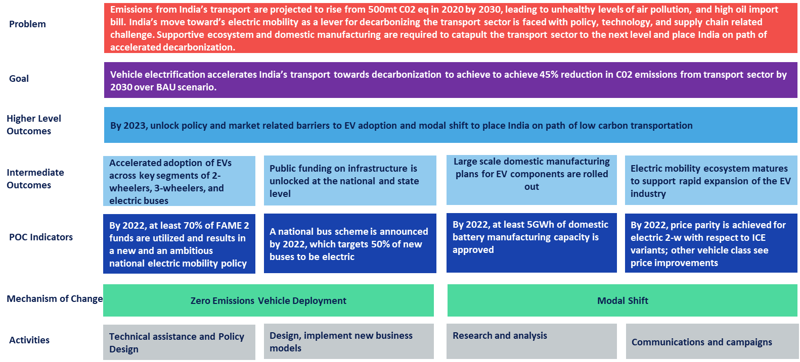

In reviewing the original ToC, OPM felt that there was a missing link between the programme activities and outputs and the PoC indicators and that the causal pathways between what the programme is doing and the higher-level outcomes and PoC indicators needed to be established. In light of this, we embarked on a process to establish Results Chains which can be considered as a mini-ToC for all workstreams through one-to-one interviews with all the partners, in order to map out the casual chains from each partner’s activities to outputs and then to the overall programme’s intermediate outcomes, outcomes, and impacts.

* 1. **Results Chains**

This is a complex programme comprising of multiple interventions and partners. To understand each partner’s intervention and their pathways of impact, partner-specific Results Chains (RCs) were further developed. The RCs help provide an in-depth understanding of how each partner intervention contributes to the overall programme’s ToC and objectives.

The results chains for each partner’s intervention were finalised through a four-step process:

Step 1: *Document review* – OPM reviewed various partner documents that were shared by CIFF, RMI and other CIFF partners regarding the interventions that were funded by CIFF. As part of document review, OPM also attended the Annual Programme Review Meeting which was held in November 2021 where RMI provided a portfolio overview and a year-end progress update of the programme. The update focused on key changes to the programme, achievements, challenges, and lessons learnt, and the next steps and priorities for Year 2.

Step 2: *Development of draft results chains* – Using the above document review and meeting notes, we developed preliminary drafts of results chains for all the partner interventions.

Step 3: *Interviews with CIFF partners* – We conducted individual interviews with partners in order to gain a better understanding about the activities which they are currently implementing, the rationale behind the design and implementation, and how they think their activities are contributing to the overall programme’s outputs, outcomes, and impact according to the programme’s Theory of Change. We also discussed the draft results chains to identify any gaps and missing links. The interview covered three main topics: Objectives, Reflection on causal pathways (Results Chain), and Learning. The detailed questions are outlined below:

**Topic 1: Objectives**

1. How would you describe the objective(s) of your project?

2. Do you feel that you are still on track of achieving these objectives and why?

3. What factors did you have to consider in designing your activities?

4. What are the main challenges and obstacles that you have faced or are currently facing with designing and implementing the project?

**Topic 2: Reflecting on causal pathways (Results Chain)**

5. Could you please describe all of your activities and what kind of ‘outputs’ do they produce? (e.g., these can be policy reports, strategy documents, training sessions or workshops that you’ve carried out or other tangible ‘products’ that are direct results of these activities)

6. How do you think the activities/workstreams carried out within your project contribute to your project’s objectives that you mentioned earlier?

7. How do you think the activities/workstreams contribute to the primary levers to decarbonisation the transport sector in India?

a. EV deployment

b. Modal shift

8. Are there any other levers that your activities/workstreams contribute to, in addition to these two levers? Could you please explain?

9. Have any of the outputs been adopted by the beneficiaries i.e., stakeholders that you have been working with e.g., the federal or state government (intermediate outcomes)? How do you know if they are adopted or not?

10. Have any of the outputs been implemented (outcomes)?

11. How do you think your outputs contribute to the KPIs at programme level?

* % of EVs in new vehicle sales in India
* $mn of FAME II funds utilised for charging infrastructure
* # of public charging infrastructure points installed
* % of buses that are electric GWh of pipeline battery manufacturing approved
* % price differential between key ICE and EV vehicle classes

12. Aside from these KPIs, how would you measure the progress of your project(s)? Do you have any other indicators (quantitative) or more qualitative measures? Could you talk me through these for your activities?

**Topic 3: Learning**

13. Given what you know now, what would you have done differently (e.g., in terms of designing your activities, allocation of resources across different activities, and how you deliver them)?

14. Is there anything else you would like to add?

Step 4: *Revisions and finalisation of results chain* – After interviews with the partners, the results chains were revised and finalised.

The section below gives a brief outline of the partner interventions and their corresponding results chains.

* + 1. **Rocky Mountain Institute (RMI)**

RMI plays the role of the key implementing partner for CIFF’s investments. Beyond managing and coordinating the work implemented by five other programme partners, RMI leads key pieces of work under the ‘Zero Emissions Vehicle (ZEV) Deployment’ mechanism (‘lever’). Focus of the activities is on bringing about regulatory reforms, working through market and technology related barriers, and improving the policy landscape.

The activities fall under the following three buckets:

1. **Technical assistance and policy design:** This is RMI’s largest pool of activities and includes projects with national and state-level stakeholders. The key interventions at the national level include work with Niti Aayog to design its battery scheme, technical assistance to the Department of Heavy Industries to support FAME II implementation, develop potential decarbonisation transition pathways for difficult-to-electrify segments, and work with Niti Aayog to support states and Union Territories in EV policy design. State-specific interventions includes working with the Maharashtra government to review and operationalize the EV policy and improving 2-W, 3-W, and e-bus adoption. RMI is also working with the Delhi government to implement the state EV policy, specifically focusing on rolling out charging infrastructure and building frameworks for incentives under the policy. These activities are expected to result in outputs such as internal and external-facing technical as well as strategy reports and documents, public tenders, operational guidelines, and ad-hoc implementation assistance. The broad objectives (‘intermediate outcomes’) for these outputs is for them to result in the adoption of policy recommendation by stakeholders as well as improvement in policy implementation.
2. **Communications and campaigns:** This pool of activities is primarily focused on implementing a National “Shoonya” campaign, in collaboration with Niti Ayog and in partnership with a set of industry players. Using a multi-pronged approach, this campaign seeks to promote the use of EVs in last mile deliveries. The expected outputs includes: 1) building a corporate branding and certification program to recognize industry players who use EVs for last-mile deliveries; 2) setting up an online tracking platform (dashboard) to monitor and understand progress in building up EV-based deliveries 3) consumer awareness drive that focuses on imparting knowledge on the benefits of urban delivery EVs and creating demand-pull/interest from consumers for zero-emission parcels. These activities have been developed through in-depth consultations with government and industry stakeholders so that there is an increase both the demand of EVs in final mile deliveries as well increased interest for EV use for last mile delivery (‘Intermediate Outcome’).
3. **Design and implement new business models:** This set of activities is focused on two interventions:1) Work with government the private sector financial institutions to develop solutions to ease financing for EVs; 2) A ‘City Accelerator Program’, based in Maharashtra (specifically Navi Mumbai and Pune), that identifies cross-cutting enablers that can be implemented for cities to support the EV ecosystem, focuses on making the cities attractive for EV businesses, and produces actionable insights that serve as guides for other city, state and national stakeholders. The expected outputs include EV readiness plans, convenings, workshops and case studies. The outputs are expected to lead to the adoption of reports as well as business plans alongside the successful implementation/scale-up of pilot/demonstration programmes (‘Intermediate Outcomes’).

These three buckets of activities will specifically result in the following ‘Outcomes’:

* Policy and regulatory barriers unlocked, leading to an increase in private and public finance deployment and increase in adoptions of EVs
* Campaign interventions result in an increase in the deployment of EVs for last mile deliveries
* Decreased barriers to finance for EVs and better access to stakeholders to improved and financially viable EV pilots result in an uptake of EVs

These are summarized in Figure 2 (2a, 2b, and 2c). RMI has mostly been on track with implementing activities, despite COVID-19, with some outputs being adopted and publicly recognized by various government stakeholders. During the last year of implementation, RMI felt that the activities have contributed positively towards larger landscape trends in terms of adoption of technologies, financing as well as in terms of approval, formulation, and approval of certain policies.

**Figure 2 Results chains for RMI**

**2a) Technical Assistance, Policy Design, and Implementation**

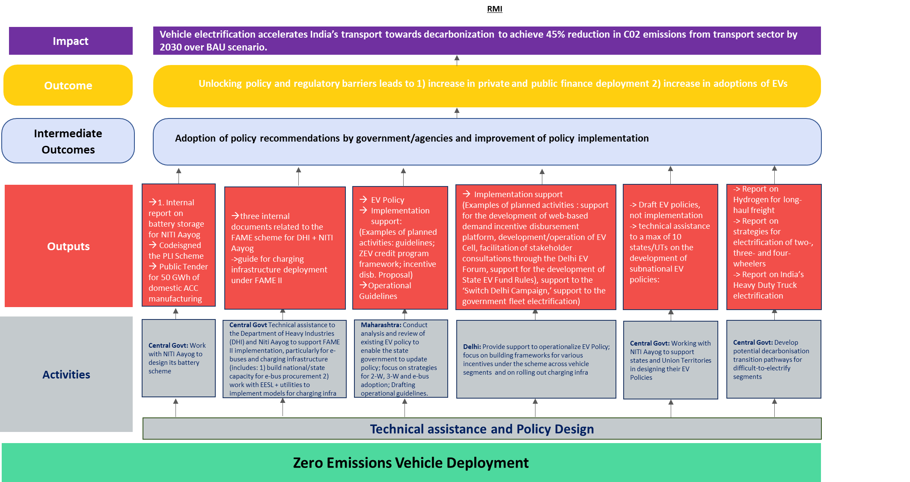

**2b) Communication and Campaigns**

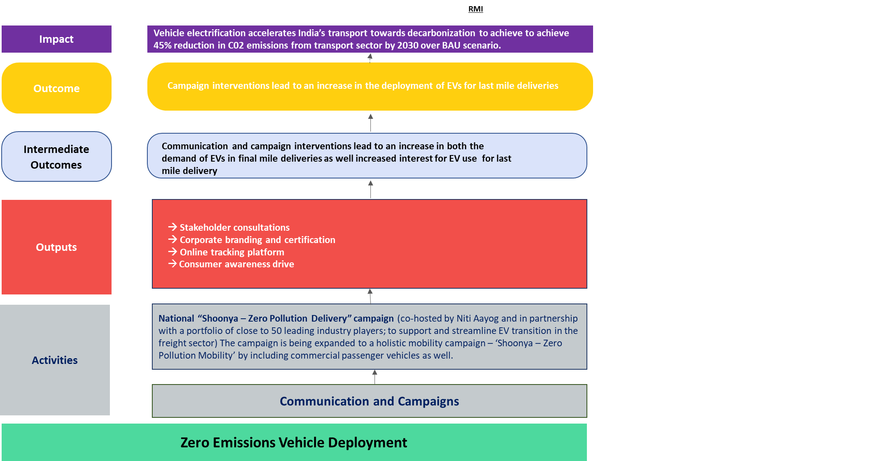

**2c) Design and implement new business models**

* + 1. **The Energy and Resources Institute (TERI)**

TERI’s work comes under the Modal Shift mechanism (lever) in the CIFF Theory of Change. TERI activities are solely research focused, aimed at increasing the share of the railways in freight transport in India, the ultimate outcome intended from this work. The logic is that encouraging a shift from road-based to railway-based freight transport, will lead to reduced emissions from the sector because hard-to-electrify heavy duty freight vehicles will be deployed less.

The main activities are research on three key topics identified in co-ordination with the Indian Railways Institute of Transport Management (IRITM), and mutually agreed with the Ministry of Railways who are the primary beneficiary: 1) Terminals: analysis and tools to inform Railways’ decision-making to reduce congestion and freight wait time at terminals, increasing operational efficiency; 2) Freight marketing policies: analysis targeting six commodities crucial for diversifying rail commodity mix; 3) Tariff fixation policy: analysing options to create a decentralised and dynamic tariff system, moving away from the current centralised model. The three topics together contribute to achieving the outcome. Activities planned and are underway include site visits, meetings with railway officials, data analysis, and best practice compilation.

Outputs are news articles, concise policy briefs, closed door dissemination seminars and full-length reports on the three topics. As per the latest Annual Program Review report, 2021, and our interview with TERI in November 2021, progress was delayed due to covid but is getting back on track. The MoUs have been completed and site visits for data collection have resumed. No output has been delivered yet.

The Railways has been closely engaged from the start of the work, which has helped define the scope of the research to match their interests. Further, TERI has MoUs in place with the Ministry and IRITM, thereby enabling access to credible data and increasing the likelihood that research outputs will be utilised to prepare Railway policies and plans on improving operations, freight marketing, tariff setting and commodity diversification. IO indicators (different from the CIFF KPIs as these focus on electrification) have been identified but will need refining with TERI. The outcome is expected to occur beyond the CIFF PoC period.

**Figure 3 Results chain for TERI**

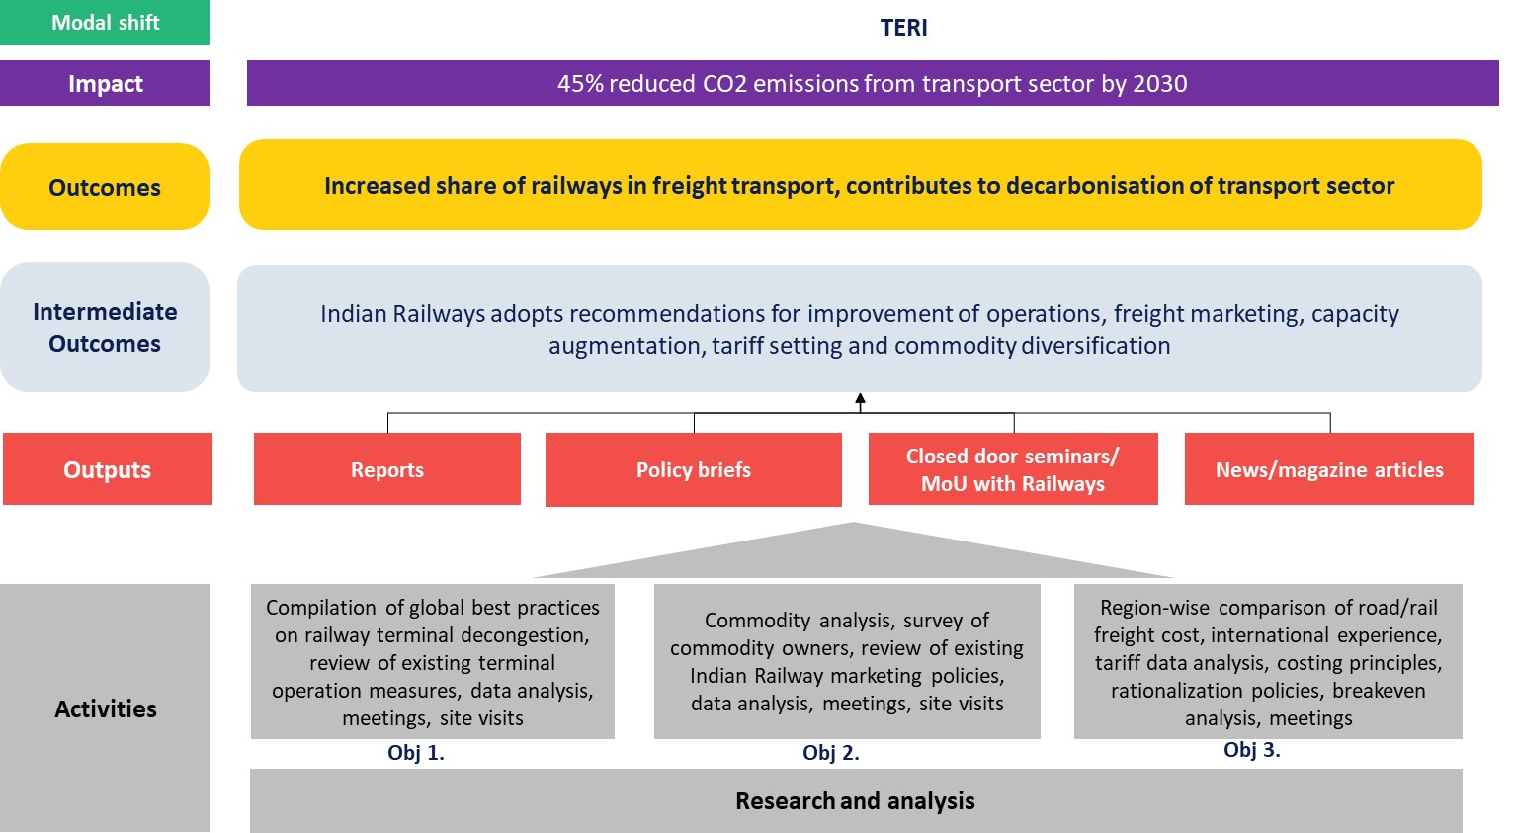

* + 1. **Urban Works Institute (UWI)**

Urban Works Institute’s project is the only other partner besides TERI working on the Modal Shift mechanism (lever) in the CIFF Theory of Change. The overarching objective of the project is to augment the quality of urban bus transport services, making them attractive and affordable for citizens to use, through multi-stakeholder collaboration supported by the Central Government. Towards this, under the umbrella of the Ministry of Housing and Urban Affairs’ (MoHUA) pan-India Transport4All Challenge (T4All), UWI is supporting MoHUA, state and city governments in developing interest and capabilities to design technical and financial assistance plans and solutions for bus transport and is creating communications campaigns aimed at citizens. This is the envisaged outcome. Electric buses are not an explicit part of T4All, however UWI is encouraging MoHUA to consider including them.

Key activity buckets are technical assistance, business model development, and communication campaigns. In conversation with UWI, we learned that an additional category, Networks, is an important tactic: UWI leverages the Sustainability Mobility Network – a network of civil society organisations active in community engagement and public advocacy on mobility issues in several Indian cities – to build citizen involvement in bus transport improvement. It has been observed that in cities where CSOs are active, and city agencies interested, those cities have greater momentum in T4All.

Technical assistance at the Centre focuses on aiding MoHUA structure technical and financial assistance to cities under the T4All programme on an ongoing basis, developing templates and guidelines for cities to conduct surveys with citizens and state transport units. For city action, state government support is critical given they control public transport decisions and finances. In turn, state interest occurs more readily when Central Govt buy-in is assured, which is cemented in this work through the T4All launch and ongoing roll-out. At the state and city level, UWI helps conduct gap assessments by engaging citizens, develops problem statements and potential solutions, helps cities structure public transport systems along the entire cycle from procurement to infrastructure, operations, financing, and communications by creating guidelines, curriculum and delivering training workshops on these components. Supporting city agencies to understand sustainable bus transport business models and viability gap funding needs, forms a key part of the project. In summary, the TA, business models, communications and network leveraging activities done by UWI under T4All, work together to produce results. Intermediate outcomes expected are state and city govts will use the guidelines, training, communications, and survey outputs to develop and test solutions for improved urban bus systems and services, and they, along with the Centre, adopts recommendations on viability gap funding schemes for public transport. It is worth noting here that the goal is to get government agencies to initiate these actions, but not completely implement it by the end of the 2-year CIFF PoC investment. Initial indicators for all TOC levels have been drawn up in discussion with UWI.

A big win was the national launch of the T4All programme in April 2021, 130 cities have registered to participate in challenge – a far more ambitious result than the 10-15 envisioned at the outset. Since then, outputs produced include tools, templates to guide cities in holding local gap assessment surveys, technical workshops in developing their vision and proposals for participating in T4All. Covid has delayed other outputs by a few months e.g., curriculum development and a few trainings.

**Figure 4 Results chain for Urban Works Institute**

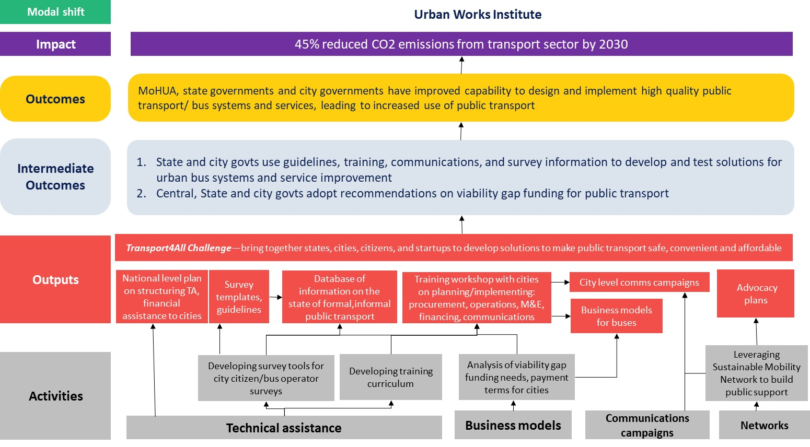

* + 1. **International Council on Clean Transportation (ICCT)**

ICCT supports the Ministry of Road Transport and Highways (MoRTH) through fuel efficiency improvements and vehicle electrification. This entails developing stringent fuel efficiency standards such as Corporate Average Fuel Efficiency (CAFE)36 norms for ICE vehicles as tighter CAFE norms will provide incentives to manufacturers to produce and sell more EVs to improve their average fuel efficiency. In the results chain interview, ICCT clarified that they produce three key outputs: working papers; best practice guides, case studies, blogs; and a policy framework that incentivises ICE vehicles, de-incentivises non-ICE vehicles and of stringent fuel efficiency standards. To achieve the outcomes of reduced barriers in adoption of a comprehensive plan for ZEV deployment and for improved emissions and fuel efficiency standards, these outputs are shared with government officials from MoRTH and Bureau of Energy Efficiency (BEE). Policy briefings and webinars are also conducted with government officials to share findings and learnings. This is because adoption of these policies rests with the government. According to ICCT, while they haven’t faced any major challenges in implementing their activities so far, they have experienced some delays due to COVID-19. They have also faced some challenges in accessing data while conducting research for an upcoming paper. The results chain for ICCT is given in the figure below.

**Figure 5 Results chain for ICCT**

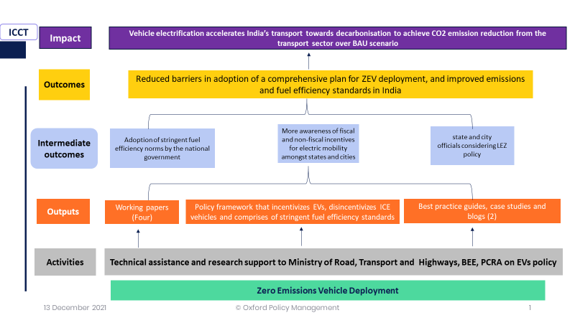

* + 1. **Confederation of Indian Industry** (**CII**)

As part of this programme, CII develops an industry platform that brings together diverse industry players in the Indian automotive sector to engage in the transition towards electric, shared, and sustainable mobility. CII has already undertaken two workshops, bilateral consultations, and platform meetings with industry members to map out barriers on the ground and identify solutions that have potential for scaling up. From the results chain interview, it emerged that initially CII were finding it challenging to get good representation and participation from each segment of the industry such as battery manufacturers and vehicle manufacturers, but they have been able to overcome this. According to CII, their activities will lead to peer learning about solutions for barriers on EV adoption, consensus building amongst industry members, and buy-in from the government. This will contribute to their aim of creating an enabling ecosystem of EV players across the value chain which will support the Indian automotive sector to transition towards electric and sustainable mobility. At the Annual Programme Meeting Review in November 2021, it was shared that CII is working on developing a white paper on 5-6 key solution areas that were identified through industry consultations. Figure 6 outlines the results chain for CII.

**Figure 6 Results chain for CII**

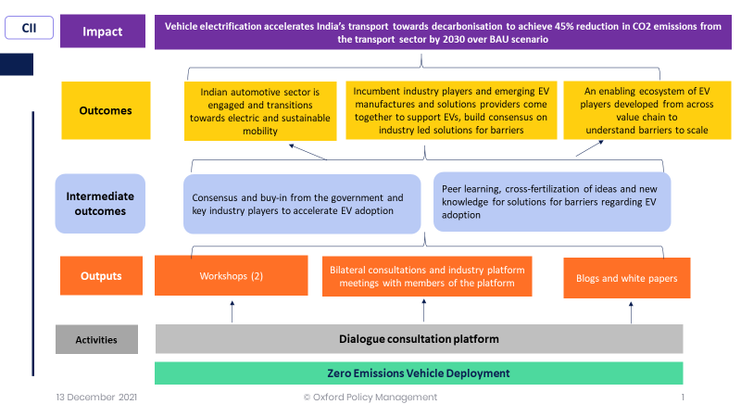

* + 1. **Edelman**

OPM had a discussion with Edelman team towards the end of the Inception Phase. Edelman’s activities focus on communications and campaigns with an overall objective to create demand and a shift in consumer’s perception towards EVs. Their activities can be divided into two strands, both focusing on EV deployment:

1. Creating communication campaigns that encourage uptake of EVs among the general public by changing their perception and attitudes towards EVs; and connecting different key stakeholders (industry, government, and infrastructure providers) to help create more collaborations and build the eco-systems for EV uptakes;
2. Providing comms support for other partners as and when it is required. For example, the Shoonya campaign with RMI – Edelman’s task was to develop branding for the campaign and creative materials (films and other comms pieces) as well as media outreach.

In designing these activities Edelman conducted research and initial survey with consumers and stakeholders in the EV chain, in order to gain a better understanding of the overall EV landscape. This helps shed a light on the gaps of perceptions and where comms activities can help fill the gaps. Edelman’s mandate was to only carry out the initial survey, but we discussed that in order to be able to measure the change in perceptions and attitudes, a post-intervention survey will be needed (ideally with the same group of respondents). This is something that OPM will also need to discuss with CIFF and Edelman further.

In terms of progress so far, Edelman feels that they are on track. COVID-19 had delayed some of the background research work and some on-the-ground activities for the Shoonya campaign. But overall, there feel confident that they would be able to meet their deliverables, pending uncertainties around COVID-19 in the future.

OPM asked Edelman to reflect on how their activities contribute to the overall programme’s objectives and outcomes and one of the main concerns is how to measure intermediate outcomes and outcomes. At output level, it is much more straight-forward to measure the progress. There are two broad output categories: (i) consumer comms campaigns (e.g., films, media articles, and campaigns) which target consumers directly; and (ii) stakeholder engagement and connection to improve collaboration among different stakeholders (government, industry, and infrastructure providers). We discussed how these outputs contribute to the programme’s outcomes and objectives and the two main outcomes are: increased demand and sales of EVs, and improving stakeholders’ collaboration, which could also help with policy adoption and implementation (TA and policy design & implementation), increased number of charging stations and infrastructure needed for EV usage, for examples. Therefore, we could consider Edelman’s activities as complementary to other partners’ activities and draw the linkages between Edelman’s outputs and, for example, RMI’s outputs. These will need to be discussed and developed further. Similarly, intermediate outcome definitions and measures also need to be finalised. We have proposed some ideas OPM has produced a note from the interview which is currently being reviewed by Edelman.

Another important thing to note from this discussion is that Edelman has identified another potential lever for delivering the programme’s ultimate objective, which is creating the networks and connections among different stakeholders. We think this is also something worth discussing further with CIFF and whether we should include this as an additional lever in the ToC.

* 1. **Theory of Change (ToC) Workshop and Revised ToC**

In December 2021, OPM conducted a ToC workshop with CIFF and its programme partners to discuss the finalised results chains (RCs) and how these would feed into revising the ToC. The workshop also included a discussion of existing indicators and how to best measure the progress. The aim of the workshop was to validate whether the ToC is still relevant, whether all assumptions are still valid, and that the ToC captures the activities and their causal links with the overall programme’s objectives.

OPM presented the preliminary draft of the revised ToC based on the reviews of programme documents, one-to-one interviews, and the RCs. This was discussed with CIFF and all the partners, gaps were identified, and the ToC was subsequently revised after the workshop. Figure 8 presents the final revised ToC which is used as a basis to guide the evaluation and the creation of the Data Management System/Dashboard.

Figure 7 Accelerating Transport Decarbonisation in India programme’s revised ToC

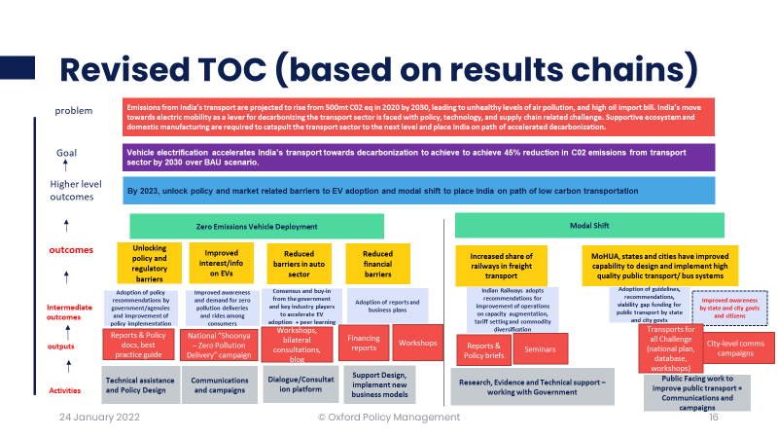

The revised ToC is split by the two levers (similar to the original ToC) and within each lever we clearly outline what the relevant outputs are for each activities, intermediate outcomes that need to happen which can lead to observable outcomes. There are four types of activities for Zero Emission Vehicle Deployment lever: (i) technical assistance and policy design; (ii) communications and campaigns; (iii) dialogue/consultation platform; (iv) support design & implement new business models. For Modal Shift lever, there are two main activities: (i) research, evidence, and technical support (working with the Government); and (ii) Public facing work to improve public transport, which includes communication and campaigns (public engagement/public facing).

The output components included in the ToC were derived from the individual RCs but summarised to make it more concise, whilst ensuring that they captured all the important elements. Intermediate outcomes (IOs) were extensively discussed during the ToC workshop as these are the most difficult to define and quantify (usually the evidence to support IOs tend to be qualitative in nature since, as the name suggest, they are the intermediate steps which signal the willingness or buy-in from beneficiaries to take the outputs further forward towards implementation. Specific outcomes are then created for each type of activity which are in line with Cascade to Impact and the programme’s objectives. All of which was discussed during the ToC workshop and then reviewed and validated by CIFF and the implementing partners afterwards. The ToC will continue to be monitored, reviewed, and adapted as the programme progresses through the learning cycle.

The team, during the inception period, has worked closely with the CIFF team and partners to: a) assess CIFF’s information needs; b) gauge partner quantitative and qualitative data monitoring capacity and frequency, especially in light of feeding into specific indicators; c) assess what the main reporting challenges are, and how they are currently being addressed; d) outlined next steps in developing reporting tools (especially at the Intermediate Outcome/Outcome Levels).

# Results Framework

The Results framework aims to highlight key linkages in the ToC that underpin the programme activities. OPM drafted the data management template which was shared and discussed with CIFF and the implementing partners. OPM also had a separate discussion with Edelman (similar to the one-to-one interview with other partners) to identity their activities, outputs and how these can lead to expected outcomes and the ultimate objective of the programme. This participatory discussion serves a critical role in building consensus and ownership around shared objectives and clarifying different interpretations of all elements of the programme. The Results Framework helps establish an evidence-based approach to monitoring and evaluation by including specific indicators of outputs, intermediate outcomes, outcomes, and impacts, indicators needed to measure progress, which helps answer the question: “How will we know that the programme has succeeded?” We have also attempted to align the Results Framework with Cascade to Impact and the key objectives of the programme as much as possible.

Table 2 presents key indicators and pathways from the Master Data Management Template, which is used as our main tool for the Results Framework and as a building block for the Dashboard (see next Section). This will be used in conjunction with qualitative evidence collected through quarterly and annual reports submitted to CIFF by the implementing partners. Our indicators intend to integrate the results from all the partners into a single ‘language’ that can be used to inform the programme evaluation framework, which we refer to as the ‘Integration Mechanism’ from MLE to Evaluation. More details of the data management system are fleshed out in the next Section.

**Table 2: Master Data Management Template/Results Framework[4]**

|  |  |  |  |  |
| --- | --- | --- | --- | --- |
| **Level in the ToC** | **Lever** | **Pathways** | **Indicators** | **Reporting Partner** |
| **Impact** | EV, Modal Shift | All | % of CO2 emission reduced compared to BAU scenario | RMI, OPM |
| **Outcomes** | **EV** | Unlocking policy and regulatory barriers; Reduced barriers in auto sector; reduced financial barriers; improve awareness and adoption of EVs | 1. % of electric vehicles in new sales 2. # of market-ready electric vehicle models 3. Number of cumulative public charging points installed | RMI |
|  | **EV** | Unlocking policy and regulatory barriers; reduced financial barriers | $ mn cumulative of FAME II funds utilised for charging infrastructure | RMI |
|  | **EV** | Unlocking policy and regulatory barriers | GWh of pipeline battery manufacturing capacity approved | RMI |
|  | **EV** | Unlocking policy and regulatory barriers; Reduced barriers in auto sector & financial barriers | % price differential between ICE and EVs | RMI |
|  | **Modal Shift** | Improved public transport infrastructure & usage | 1. # of cities with bus schemes under the new National Scheme 2. % of buses which are electric 3. % of people using public transport | RMI, Urban works |
|  | **Modal Shift** | Increased share of railways in freight transport | % of freight transport by railway | RMI, TERI |
| **Intermediate outcomes** | **EV** | Unlocking policy and regulatory barriers | # of policy recommendations adopted | RMI, ICCT |
|  | **EV** | Reduce barriers in auto sector; Reduce financial barriers | 1. Consensus and buy-in from the government and key industry players established to accelerate EV adoption + peer learning   2. % decrease in battery prices  3. # of car companies' acceptance of policy on selling EVs with swappable batteries, and new technology designs for vehicles and infrastructure  4. # of EV projects implemented by government agencies | CII  RMI |
|  | **EV** | Improved awareness of EV | # of impressions and views of the ad film (there are others to be defined in discussion with Edelman) | Edelman |
|  | **Modal Shift** | Increased share of railways in freight transport | # of recommendations adopted by Indian Railways for improvement of operations on capacity augmentation, tariff setting and commodity diversification | TERI |
|  | **Modal Shift** | Improved public transport infrastructure & usage | 1. # of guidelines, recommendations adopted by state and city govts 2. Amount of viability gap funding for public transport provided by state and city govts 3. Improved awareness by state and city govts and citizens (need to discuss further on how to measure this) | Urban Works |
| **Outputs** | **EV** | Unlocking policy and regulatory barriers | 1. # of policy and regulatory recommendations 2. # Trainings/webminars | RMI, ICCT |
|  | **EV** | Reduced barriers in auto sector | # Online tool and platforms developed | CII |
|  | **EV** | Reduce financial barriers | 1. # Convenings/workshops about business models with key stakeholders 2. # Published papers and reports on EV financing 3. # of electric mobility solutions/strategies piloted | RMI |
|  | **EV** | Unlocking policy and regulatory barriers (city level) | 1. # Convenings/workshops about business models with key stakeholders 2. # of policy and regulatory recommendations 3. # Online tool and platforms developed | RMI |
|  | **EV** | Improve awareness and adoption of EV | 1. # Online tool and platforms developed 2. # Trainings/webminars 3. # Comms pieces produced | Edelman |
|  | **Modal Shift** | Increased share of railways in freight transport | 1. # of policy and regulatory recommendations to increase railways in freight of transport 2. # of Trainings/Webminars/Seminars 3. # Comms pieces developed | TERI |
|  | **Modal Shift** | Improved public transport infrastructure & usage | 1. # of policy and regulatory recommendations for improving technical and financial capacity of cities 2. # Online tool and platforms developed 3. # of Trainings/Webminars/Seminars 4. # Comms pieces developed | Urban Works |

# Tracking Evidence: Dashboard Concept Note

This section introduces the conceptual design of a data management system to enable the programme to track progress over time via a dynamic dashboard. The suggested approach of the dashboard and the data management system is based on an analysis conducted on the current data system; a revision of secondary data sources; conversations with key stakeholders, including CIFF and implementing partners; and on the understanding that OPM has of the needs that the dashboard is expected to respond to.

A key element for the content of this approach is that the system should respond to the capacities of the programme, so that CIFF can continue the dashboard’s administration once OPM’s involvement ends and that it should consider a friendly strategy for the partners to input data on a regular basis (quarterly).

The section is divided into six part: i) description of the current data system and its challenges to inform a dashboard systematically; ii) description of a new reporting system to feed into the dashboard effectively and sustainably; iii) the role that the partners will play in reporting key results on quarterly basis[5], iv) role of the M&E team to gather, analyse, and enter secondary data sources in the reporting system, v) components and content of the dashboard, and vi) software and expected costs of the implementation and administration of the dashboard and its online dataset.

* 1. **Current data system**

Based on conversations with key stakeholders, including CIFF and its partners, and on the analysis of the documents to which OPM had access during the inception phase, it is understood that the data system which currently informs the programmes’ indicators is divided into two main sources: (i) progress reports from partners; and (ii) a repository of indicators that are informed by secondary data sources. These sources of information are described below:

**Partners’ reports**

Every partner reports progress to the programme every six months using a MS Word Document template that includes a detailed narrative of each partner’s objectives and progress made during the period. For each partner, the report includes a matrix where specific key deliverables are reported against.

**Repository of secondary data sources**

It is an excel file *(C2I_revised_august_2021.xlsx)* that works as a repository of indicators that are informed by secondary data sources[6]. A team in RMI collects data from different data sources, analysises it, and creates tables with the value of key indicators in different periods of time[7] (the reporting frequency of the indicators is not consistent). The excel file includes 10 different tabs where different indicators are stored. Some of these indicators are considered in the indicator matrix presented in section 5.4 below (and in Section 4 above).

The combination of both primary sources in the form of text narrative and a repository of indicators informed by secondary data sources makes the current data system to be very effective in many dimensions which include:

* Ability to capture progress made by partners against their milestones and their status,
* Capacity to collect a rich narrative about the relevance of the partner’s activities,
* Possibility to understand partners’ priorities and follow up points for future periods, and
* Ability to organize indicators informed by secondary data sources periodically.

Although the current system is effective in the points mentioned above, the way its data is structured is not effective to aggregate information at the programme level and to systematically feed a dashboard that tracks progress at the programme level.

The main challenges of the current system to inform a dashboard are the following:

* Every partner reports independently using MS word, which implies that the data is not formatted in a manner that a dashboard can “pull” the information from,
* The milestones and indictors are partner specific (each partner reports different milestones) which makes it impossible to aggregate at the programme level,
* The process to capture programme level indicators from every report and to include them into a single database would be extremely time consuming and costly[8],
* Although the repository for secondary data sources is stored in an excel file, the format for each indicator is different which will cause problems to continuously inform a dashboard.

Thus, based on the strengths and challenges mentioned above, OPM suggests complementing the current data system with one that allows a systematic reporting of achieved results, that is consistent with the programme’s level indicators (see section 5.4), that allows an effortless aggregation of results, and that can inform a dynamic dashboard every time new information is added into the system.

## Proposal of a complementary data system

Based on the review conducted to the current system, it is understood that integrating the results from all the different partners and the secondary data sources into a format that allows an effective aggregation of indicators that are aligned to the programme’s indicator framework would be extremely time consuming and costly. For example, to be able to produce a database that could systematically feed the dashboard, a team of analysts would need, on every reporting period, to analyse every partner’s report individually to try to identify milestones that can be translated into a program indicator, and then this team would need to document this into a separate database that could be ‘connected’ to a dashboard. And this effort would need to be replicated for every reporting period. Thus, to try to implement a mechanism that translates milestones into programme’s indicators and that can ongoingly aggregate results to track progress would be very complicated and costly under the current system.

Therefore, OPM suggest a new data management system that will allow a simpler reporting strategy in which the partners can report against the programme’s indicators directly, that can facilitate the storing and querying of the data, and that has the potential to feed both a dynamic dashboard to track progress over time and provide relevant qualitative information to other reporting needs.

The suggested data management system that is summarised in Figure 1 below, would be based on an online form that will allow the partners to report results that are aligned to the programmes indicators (See Section 4). Thus, instead of having a separate file for each partner every reporting period, all the partners will report in the same place and the data will be stored into a single database which will be updated automatically every time that a new result is added to it.

Moreover, it is suggested that an M&E team[9], instead of reporting indicators informed by secondary data sources into an excel file, they will update the value of these indicators in the same online form.

Figure 8: Suggested Data Management System to Inform Progress

The main benefits of this suggested approach are the following:

* The number of files in which the data is stored will be reduced from many MS Word documents to only one database that stores data in a friendlier format to conduct analysis.
* The indicators informed by secondary sources will be stored in the same database as the ones informed by the partners.
* The indicators will be aligned to the programme’s evaluation framework which will make their aggregation feasible.
* The data base will always be up to date and will be updated every time that new information is entered to it.
* The data can be always accessed in an online platform and can be exported into various formats (i.e., csv, xlsx) which would facilitate its ongoing querying.
* The data will be stored in a format that will allow a seamlessly connection to a dynamic dashboard with no need to conduct preliminary manipulation of it.

It is expected that all these gains will reduce the amount of time needed to transform the raw data into a format that is friendly to be analysed either for a dynamic dashboard or for any other purpose.

The next sections introduce the system in more detail, including the role that different stakeholders will play, description of the online forms, software, and potential costs.

## Role of partners to report results

The partners will have access to an online form ([see example](https://creatorapp.zohopublic.com/araupontones/ciff/page-perma/Partners1/FX8K6B82aVay7SVzXH9JTaq4Mf4pz4hH8qWDZtuV7vFjYngaHKbEesEPWWDXOHCs2FhXrRYBZDRFA5NbJB1pf38vBhK657JQqKRN)) in which they will report the following:

* Period of the report
* Type of results: whether the achieved result is an Output or an Intermediate Outcome[10]
* Number of results: the number of results of these type that are reporting (e.g., 3 trainings)
* The pathway[11] that best describes the objective of the result: this is aligned to the ToC pathway,
* And a brief description of what the result was about and what is its relevance to the programme.

Figure 9: Example of Online Form for Partners

To ease the reporting experience of the partners and to assure that all feel comfortable about how and what to report into the system, OPM will distribute a guideline to each partner. These guidelines will include a dictionary that associates results with the programme’s indicators and relevant points to add to the description of each of the results. Examples of these guidelines are presented in the Annex B. Moreover, OPM could facilitate a training[12] for the partners to learn to associate their results to the programme’s indicator framework.

Part of the work conducted during the inception period was to map all the partners’ activities and objectives. Thus, it is expected that the list of results included in the system will fit all the dimensions that the partners could report against, which is our ‘integration mechanism’. To increase the chances of every partner being able to report against the results defined in the system, OPM suggest using the first reporting period as an opportunity to pilot the system and to make corrections if needed.

## Role of M&E team to report on secondary data sources

Thus far, the evaluation framework is informed by nine indicators that come from secondary data sources (See Table 3 below).

Table 3: Indicators informed by secondary data sources

|  |  |  |
| --- | --- | --- |
| **Levels ToC** | **Levers** | **Indicator** |
| Impact |  | % of CO2 emission reduced compared to BAU scenario |
| Outcome | Zero-Emission Vehicles | % of electric vehicles in new sales |
| Outcome | Zero-Emission Vehicles | # of market-ready electric vehicle models |
| Outcome | Zero-Emission Vehicles | % price differential between ICE and EVs |
| Outcome | Modal Shift | # of cities with bus schemes under the new National Scheme |
| Outcome | Modal Shift | % of buses which are electric |
| Outcome | Modal Shift | % of people using public transport |
| Outcome | Modal Shift | % of freight transport by railway |
| Int. Outcome | Zero-Emission Vehicles | % decrease in battery prices |

Because these indicators are informed by different sources, the new system suggests that the same team that calculates these indicators, could report against them using an online form ([see example](https://creatorapp.zohopublic.com/araupontones/ciff/page-perma/Secondary_Data_Sources/mpNYpP3xgwXGDk93DHVGar0DevKNnTS1bwkJz9fZB69mA9VNQmHMVdUx4JBnyVm1SX1tWs7svsz0KXZ36xaqPOzsuxfBNnWABfzQ)). Thus, every time that an “external” indicator has been updated, this team will enter this information into the system. For each the indicator, it would be expected to provide the following information:

* Year
* Report period: whether if the update is quarterly or bi-annually,
* To which level of the ToC the indicator belongs to (Int. Outcome, Outcome, Impact),
* The name of the indicator to be reported, and
* The value of the indicator.

An example of the online form to update the indicators from secondary data sources can be seen in Figure below. As it will be done for the indicators reported by partners, OPM will create a guideline to facilitate the entering of this data.[13] This guideline would include information about the frequency and the source where the indicator can be found[14].

Figure 10: Example of Online Form to update indicators from secondary data sources.

## Content of dashboard

The objective of dashboard will be to communicate and track the progress that the programme has made to meet its objectives over time. In this sense, the content of the dashboard will mimic the structure and narrative of the Theory of Change (ToC) that was described in section 3.2. Thus, it is expected that the dashboard will be divided into two main sections or pages, one to track results of the Modal Shift lever and another to track progress made under the ZEV or EV Deployment lever. To reassemble the structure of the ToC, each page will be organized by the level of the indicators (Outputs, Intermediate Outcomes, Outcomes, and Impact).

Although all the indicators will be aggregated and the visuals will show the cumulative number of results, the user will be able to dynamically slice the data by reporting period, by pathway (see Section 4), and by partner. The ability for the user to filter the data by these dimensions will ease the understanding of what the contribution of each of these have had to meet the targets.

In terms of content, the dashboard is expected to display all the indicators included in the indicator matrix that are quantifiable, and that are reported in the online forms presented in the previous section. Thus, the visualizations embedded in the dashboard will include only those indicators for which an aggregation can be implemented (which are most of the indicators). Those indicators that are qualitative by nature will be reported in other reports of the M&E system e.g., quarterly (narratives) report.

Another useful feature of the dashboard is that it will include a table with all the results reported in the online forms with the description or details that the partners provided about them. The aim of this table, that could be filtered dynamically by partner and/or period, is to facilitate the understanding of the relevance of each result and the context in which it occurred.

As it was mentioned above, the data that will inform the dashboard will be the one that is collected via the online forms. The reason for suggesting this approach is that the data from the online system can be linked directly to Power BI which is the suggested software for the dashboard. This approach will assure that the dashboard will always be up to date. Below is an example of how a page of dashboard will look like.

Figure11: Example of dashboard

## Software and costs

The table below summarises the software that will be used to program the dashboard and the costs related to each. It is recommended that all the payments to the different platforms are made directly by CIFF because this will reduce dependency on OPM in the future.

**Table 4: Software needed and cost for the dashboard**

|  |  |  |
| --- | --- | --- |
| **Software/platform** | **Use** | **Cost** |
| [Zoho creator](https://www.zoho.com/creator/) | To programme online forms and store data online. | OPM will bare the costs during the first reporting period. However, if CIFF desires to have full access and ownership, a new subscription should be paid. The monthly cost is 125 EUR. |
| [Power BI](https://powerbi.microsoft.com/en-us/) | To develop and deploy dynamic dashboard | Power BI is a free source, but an upgrade would be required in case the dashboard is to be shared publicly. The monthly cost for a license is 9.99 USD. |
| SharePoint | To store the dashboard and share it internally. Although this software is not imperative, having it would allow CIFF to share the dashboard internally and for all the administrators to have access to its design. |  |
| GoDaddy | To customize the domain of the online forms. Having a customed domain would facilitate the users to remember the URL used to access the forms online. It is highly recommended to avoid having very long URLs. | 20 Euros for a two-year subscription |

# Learning & Reflection

OPM has particular expertise in integrating learning within an overall MLE system, going beyond monitoring progress to understand why and how change has happened and the implications for future investments. It has the potential to improve the effectiveness and efficiency of the programme, as well as enhance its impact by informing and influencing the work of others. A set of learning topics will be drawn up and finalized in consultation with CIFF and partners based on level of collective interest, extent of new insights on technical and tacit approaches to impact change, the potential for replication, and identification of a clear target user. Workshops, interviews with partners, and case studies will be the key activities producing learning insights for the project, in addition to reporting documents.

## Purpose of the Learning System

The Learning System intends to support the evaluation process, derive programmatic and wider thematic learnings to shape future CIFF’s and partners’ programmes, as well as inform and influence the work of others in the transport decarbonisation space. We will use **internal and external ‘learning-loops’** that allow CIFF and the partners to learn through the process of implementing the PoC investments and therefore, strengthen the future investment design and delivery of follow-up investments in the transport sector. The learning will be captured through the annual reporting process, biannual learning workshops, and standalone case studies. The purpose is two-fold:

* ***Internal learning***: **To learn from successes and failures of the programme.** We will support CIFF and implementing partners to reflect on successes and failures of their projects (including M&E findings) and aid decision making in the programme (*internal learning-loop)*. The Learning System intends to strengthen internal performance as well as facilitate internal uptake of learnings across each of the four types of ‘activities’ funded by CIFF. This process should aid decision making in the programme and help facilitate an adaptive programme management approach.
* ***External learning***: **To influence and inform the work of others.** Documenting and communicating to an external audience (through case studies) learning on both the technical approaches and tacit processes that have delivered results under the programme *(external learning loop).* It will likely be helpful to narrow the topic of the case studies to more specific learning questions, for example, learning on how to accelerate innovative finance and business models for electric vehicles. The objective and format of this will need to be discussed further with CIFF.

We believe that these are aligned with CIFF’s learning priorities for course correction and wider learning outlined in the ToR:

* What key course corrections should CIFF, and its partners make in any future investment beyond the PoC?
* What wider key lessons and learning has the PoC investment generated in the field of accelerating transport decarbonization?

## Key principles of the learning system

The following are the key principles which will guide the design and delivery of the learning component:

**Targeted design and clear scope**: To ensure the learning is impactful, we will identify a set of overarching learning topics at the beginning of the programme (but with the flexibility to adapt them as the programme develops) and focused on questions that are not only relevant to the programme, but for which there is a key target user of the learning.

**Commitment and time investment by partners and CIFF**: OPM will manage the Learning System and facilitate a set of learning activities, but the actual learning will need to come from CIFF and the partners. All partners will need to be fully committed to the value of participating in learning activities and be willing and able to invest staff time. An integral part of a commitment to learning, is a willingness to be open and honest, and share both successes and failures with partners and CIFF. Similarly, the learning outputs should be co-produced by OPM, the partners and CIFF which will also help facilitate uptake of the learning within these organisations.

**Leverage other programme activities for external learning dissemination**: The external dissemination and uptake of learning outputs will primarily rely on opportunities which emerge through the programme and the partners’ wider set of partners, such as workshops and conferences being convened on relevant topics. Wider reach of the outputs can be achieved by CIFF and partners featuring them on their websites or promoting them on social media platforms.

Rather than linking learning to the measurement of progress and results within the programme[15], internal learning will be focused on themes and different approaches, which helps the partners to think more holistically, as well as be honest about the challenges they are facing. Internal learning also forms a vital part of our evaluation questions, which will help inform CIFF in the design of their future investment.

## Framework for the Learning System

The overarching framework for the Learning System will involve a set of four activities (the last step i.e., ‘uptake’ will be discussed with CIFF whether this is feasible given the timeline of OPM’s engagement with the project). It will start by setting a limited number of specific learning questions (with accompanying target users of the learning), and then facilitate a series of activities to capture learning from the partners. Separate activities will help communicate the learning internally and externally. The figure below summarises the key steps for the learning system:

Figure 12: Learning system for accelerating transport decarbonisation

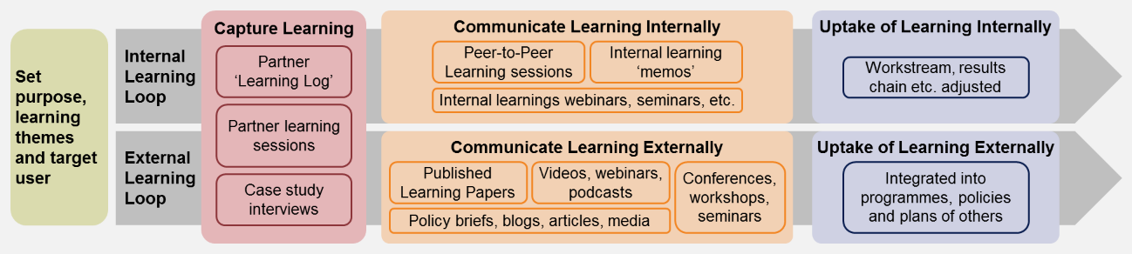

The rest of this section outlines each of these steps in turn, providing an outline of the type and scale of activities that will be supported.

**Step 1: Set purpose and target users:** We will brainstorm with CIFF and implementing partners to arrive at a provisional list of 2-3 learning topics (examples in the below table), which will be the focus for learning initially, but can be amended as the programme processes. We will aim to first identify a long list of learning topics which will then be further narrowed down to allow for a range of types of topics. This will be discussed further with CIFF and implementing partners prior to the first learning workshop in April 2022.

The following criterion will be used to select and prioritise these learning topics:

* Is this learning topic going to produce some new insights that are not well-known to others, and do they have the potential to be replicated and adapted?
* Does the learning topic include learning about technical approaches as well as tacit processes (e.g., the different ways the programme has been able to influence governments or leverage different voices for advocacy)?
* Is there a clear target user for the learning? What is the likelihood that they will use it?

The learning topics have both an internal and external learning purpose. They are intentionally high level and applicable to the range of different interventions the partners are undertaking. For each learning question, a specific target user will need to be identified.

The learning questions will expand on and address the learning-oriented evaluation questions. They will align to the set of learning topics, and to the Theory of Change. They aim to be sufficiently broad in order to capture lessons across partners, covering both ZEV/EV and Modal Shift mechanisms, unpacking what has worked, not worked and why, and if the assumed causal pathways are still valid, in both cases. A purely indicative set of topics and questions, from our early understanding of the programme so far, are tabulated below to give a sense of the kind and depth the learning will explore. However, we will speak to CIFF, and partners use the initial learning session to arrive at a list of topics and questions and find the unique points of learning for CIFF.

**Table 5: Indicative learning topics (to be discussed further)**

|  |  |  |
| --- | --- | --- |
| Learning Topic | Learning Question(s) | *Assessing the ToC* |
| **Political economy** | * What is the programme learning about political economy enablers (incentives) and barriers (disincentives) to accelerate transport decarbonisation and public transport improvement and use in India? How can these incentive structures be adjusted or influenced? * Are there lessons on working with opponents of decarbonisation (e.g., industry players) in transport? | *Assumptions around intermediate outcomes e.g., adoption, political buy-in* |
| **Influencing pathways** | * What is the programme learning about how to influence the actions and decisions of different stakeholder groups, particularly in terms of the more implicit, tacit, or indirect modes of influencing? * What decision-support tools, analysis, communication methods or formats, are emerging as the most effective way to deliver outcomes? Do these vary by kind of project, location, type of stakeholder, mechanism type, and if so, how? * What other external factors have contributed to achieving outcomes? How important was the relative influence of the POC investments? * Have any efforts not produced expected results? What were the key factors preventing outcomes, and are there indications of what strategies could help overcome barriers? | *Pathways are correctly identified, external factors (enablers & challenges), unintended consequences* |
| **Leveraging programmes and partnerships** | * What are the different ways that the programme has leveraged partnerships, funding and other resources from other programmes or networks? What have we learnt about how to do this, and the value of it? | *Potential additional lever to be added to the ToC?* |
| **Relevance, sustaining results** | * Are the four tactics the most effective and efficient way of achieving the KPIs? * Which are the major gaps in POC efforts to achieve decarbonisation that should be considered for future investments? (e.g., 4-wheelers and heavy-duty freight vehicles) * Do the POC investments align well with the broader transport decarbonization private sector agenda and policy context in India? Should any tactic be focused on less or more in the next phase, depending on how the sector has evolved? * Do the POC investments align well with broader funder and grantee ecosystem? * How is the programme ensuring the sustainability of the changes it is supporting? How is it influencing future decisions and actions, beyond the duration of the programme? * What key course corrections should CIFF, and its partners make in future investments beyond the POC? | *Sustainability and course-correction towards higher-level outcomes and impact* |

**Step 2: Capture learning:** We will use a structured process of capturing learning from CIFF and the programme partners, which uses the findings from the monitoring and evaluation work but investigates *why* results happened. In agreement with partners, we will use the following learning tools, but we will regularly reflect on their utility, adjust as required and explore alternatives:

* *Sharing of programme activities, events, and outputs*: To help facilitate collaboration and coordination of partners, as part of the learning system and beyond, we will set up a system for the programme partners to share key programme activities, events, photographs, and outputs. This could be a SharePoint based system, so that all partners can access it. It might be worth considering establishing ‘learning logs’ as part of their regular reporting process (quarterly and annually) where each partner provides rough notes and reflections on the learning questions. This could be added to the quarterly report template, for example.
* *Learning workshops*: OPM will facilitate two learning workshops during the course of the evaluation period. They will serve the purpose of both identifying and documenting learning which will feed into case study preparation. The agenda for these could include: a) discussion on learning from the biannual evaluation conducted by OPM; b) dissemination/validation of M&E data; c) deep dive to assess adaptive programme management.
* *Evaluation case study interviews* ***–*** Evaluation case studies will be carried out for the purposes of evaluation, assessing the question of contribution and for capturing learning. We will use key informant interviews of the partners, government officials, industry, and other beneficiaries (freight companies and potentially consumer survey – potentially working together with Edelman) to tease out not just the impact of an intervention, but also what was learnt in the process.

The outputs from these learning processes i.e., ‘learning insights’ will be written-up as part of our bi-annual reporting to CIFF (the first learning insights will be incorporated into the Half-Yearly Report and the second learning insights into the Final Report).

**Step 3: Communicate learning:** The learning insights will provide the vehicle to communicate learning from the programme to a wider audience. We expect the learnings to be informative for external audiences engaged in transport decarbonisation issues and could be disseminate more widely either through CIFF’s website or social media. We will discuss with CIFF the content and format of such dissemination.

**Step 4: Uptake of learning (TBD):** We could help CIFF monitor and report on uptake of the learning, including among implementing partners and external actors.

For the internal learning loop, the uptake of learning will happen throughout the duration of the programme, and primarily in parallel to mapping and discussing the learning during the learning sessions involving the partners.

For the external learning loop, we could set certain indicators for measuring uptake (which are separate but complementary to the programme’s overall results framework) to track both dissemination (e.g., number of downloads of the paper) as well as impact (e.g., anecdotal evidence of how the learning has informed and influenced the work of others. This could potentially be discussed with CIFF and Edelman who are working on comms activities.

# Risk mitigation

OPM has the international experience and expertise to conduct this assignment and deliver high quality outputs. However, we have identified some risks to the delivery of the assignment.

**Table 6: Risks and mitigation strategies**

|  |  |  |
| --- | --- | --- |
| **Identified Risks** | | **Mitigation Strategy** |
| **Data Sharing** | Our monitoring, learning and evaluation reporting relies heavily on the data reported by the partners, and there is a risk that of insufficient data-sharing from partners. | * OPM will ensure that timelines for data collection and submission are communicated to partners well in advance to prevent any delays |
| * OPM will take an active role in assisting partners develop their internal tracking of results. This includes tool development as well as regular meetings with point persons for each partner |
| * For secondary data (‘macro’ data), OPM will look beyond partner reporting to ensure that data points are validated through other sources |
| **Insufficient Evidence** | Partner reporting may not provide us with the evidence needed to support the claims. | OPM will seek external sources of data, interviews with stakeholders/CIFF programme team to understand whether programme interventions are on track to meet milestones. |
| **Lack of partner collaboration for the Learning component** | Finalising topics and working towards building a narrative for our learning papers requires ongoing input from both partners. Partners may not be able to provide adequate/timely inputs. | * The learning approach set out in this inception report is built on several layers of knowledge-gathering. OPM will use existing monitoring and evaluation reporting to expand on specific topics and participate in partner events etc. to gain direct insights as well as programme outputs (such as reports, assessments, workshop recordings). |
| * For learning products that focus on programmatic learning, OPM will lean on CIFF’s MLE and programme team members to tease out relevant lessons. |

Annex A: MLE Reporting Template

# Summary and Overview of Progress

# MLE Process

## Update on MLE Activities

## Update on Learning Workstream

# Programmatic Reporting Against Logframe Indicators

## Detailed Output Reporting

## Detailed Intermediate Outcome Reporting

## Detailed Outcome Reporting

## Progress against key macro indicators/KPIs

# Evaluation of Programme Interventions (against Evaluations Questions)

# Challenges

## MLE Challenges

## Implementation of Activities

* Learning insights

# Recommendations

## Lessons Learnt

## Recommendations for adaptive programming

Annex B: Example of Partner’s Guide to Report Against ZEV/EV Related Results (to be finalised)

**Outputs**

|  |  |  |
| --- | --- | --- |
| **Type of result** | **What to report against this result?** | **What to add in the description of the result?** |
| **Communication pieces developed** | * Blogs * Communication pieces * Billboards * News and magazine articles * Films | * Date of publication * Who is the main audience? * How many people is the campaign expecting to reach? * What is the main objective of the campaign? |
| **Trainings/Webinars/Seminars** | * Seminars or webinars convened * Convening with all states for state EV Accelerator launch, Delhi * EV Forum convenings * Webinar on battery storage | * Date * Duration in days * Which organizations attended/participated? * How many people attended/participated? * What was its main objective? * What was its content? * What type of actions are expected from the event? |
| **Tools and platforms developed** | * Database of information * Shoonya website and Number of Online Tools on the Shoonya website * Web-based platforms and systems developed for cities * Platforms for convening auto industry and peer discussion | * Date of deployment * Who are the main expected users of the tools? * How does the tool is expected to be used? * Which results are the tools expected to facilitate/incentive in their users? |
| **Policy recommendations for improving technical and financial capacity for government** | * Plans for structuring technical, financial assistance to cities * Policy and regulatory papers/recommendations * Guidance documents produced * Ad hoc technical analysis * Published reports for central, federal, and city-level governments | * Date when the recommendation was provided or published * To which organization(s) was the recommendation provided * What is the main objective of the recommendation? * What is the political relevance of the recommendation? |
| **Convenings/workshops about business models with key stakeholders** | * Interviews organized on EV financing issues (Business Model) * Accelerator workshops * Convenings organized on EV financing | * Date * Duration in days * Which organizations attended/participated? * How many people attended/participated? * What was its main objective? * What was its content? * What type of actions are expected from the event? |
| **Published papers and reports on EV financing** | * Published reports and briefs on EV financing * Published reports on perception and uptake of EVs | * Date * Who is the audience? * What is the main objective and relevance of the publication? |
| **Electric mobility solutions/strategies piloted** | TBD |  |

**Intermediate Outcomes**

|  |  |  |
| --- | --- | --- |
| **Type of result** | **What to report against this result?** | **What to add in the description of the result?** |
| **Guidelines/recommendations adopted by state and city govts** | * When there is evidence that states, or cities have improved capability to design and implement high quality public transport/ bus systems because of support provided by the programme * Policies notified, Schemes approved, public tenders issued, regulatory notifications notified in gazette, Budget outlays sanctioned/increased (by government agencies both national and city level) | * Date when the recommendation was provided to the government. * Name of the recommendation provided (so it can be traced in the system). * Name of the government agency that adopted the recommendation. * Relevance of the adoption. * Expected positive impact of the adoption. |
| **Impressions and views of comms campaigns and activities** | * Number of people reached for a particular campaign, news article, etc. (TBD with Edelman further) | * Start date of the campaign. * Main objectives of the campaign * List of platforms in which the campaign was disseminated. * Who was the target audience of the campaign? * How does the campaign expect to impact its audience? (Which type of behaviour, knowledge, or practices?) |
| **Car companies' acceptance of policy on selling EVs with swappable batteries, and new technology designs for vehicles and infrastructure** | * When there is evidence that a car company has accepted a new policy on selling EVS with swappable batteries * Acceptance of new technology designs * % Decreased battery price | * Name of the car company that accepted the new policy. * Description and relevance of the new policy. * How does the new policy is expected to impact the EV market? |

1. This could be combined with the second learning workshop – to make it an external learning exercise.
2. Final dates to be confirmed and agreed upon with CIFF
3. Theory of Change is the theory of how the intervention is expected to work (setting out all the steps expected to be involved in achieving the desired outcomes), the assumptions made, the quality and strength of the evidence supporting them, and wider contextual factors. a Theory of Change typically involves considering the proposed inputs (what investment/regulation/actions will take place) and the causal chain that leads from these inputs through to the expected outputs and outcomes. It considers the causal mechanisms by which an intervention is expected to achieve its outcomes, basing this theory on the gathering and synthesis of evidence.
4. . We also need to still identify the milestones and corresponding dates for deliverables with the partners in order to track the progress, and this will be followed up immediately after the Inception Phase.
5. Macro KPIs may be reporting on an annual basis, but all other lower indicators will be reported quarterly.
6. Some of the data sources include <https://vahan.parivahan.gov.in/vahan4dashboard/vahan/view/reportview.xhtml> and <https://fame2.heavyindustry.gov.in/ModelUnderFame.aspx>
7. This information was provided by RMI during a bilateral call with OPM.
8. This process would require a team to carefully analyse every report to try to find narratives that could be translated into programme level indicators. Because the reports are mainly text, this process should be conducted manually for every report and every reporting period.
9. The work of collecting secondary data sources is currently conducted by RMI and it is suggested that their team could be responsible for updating these indicators in the new system.
10. In the indicator Matrix, partners only inform at this level. All the indicators for outcome and impact come from secondary data sources.
11. Each indicator is attached to its associated pathways. Thus, when an indicator is selected only its associated pathways will be eligible as options in the dropdown
12. The topics that would be covered in this training include how to access the online forms, how to report and frequency, how to solve any issues/questions, etc. We can include CIFF in this training so that CIFF will also have experience with the system.
13. For this we would need support from RMI to map the exact sources of each indicator and to define their scope (are they national? Regional? City?
14. OPM would need support from RMI and the other partners to map the sources of the indicators and their geographical coverage.
15. To be efficient, the partner learning log may be considered as part of the partners’ reporting tools – which is to be discussed further with CIFF.